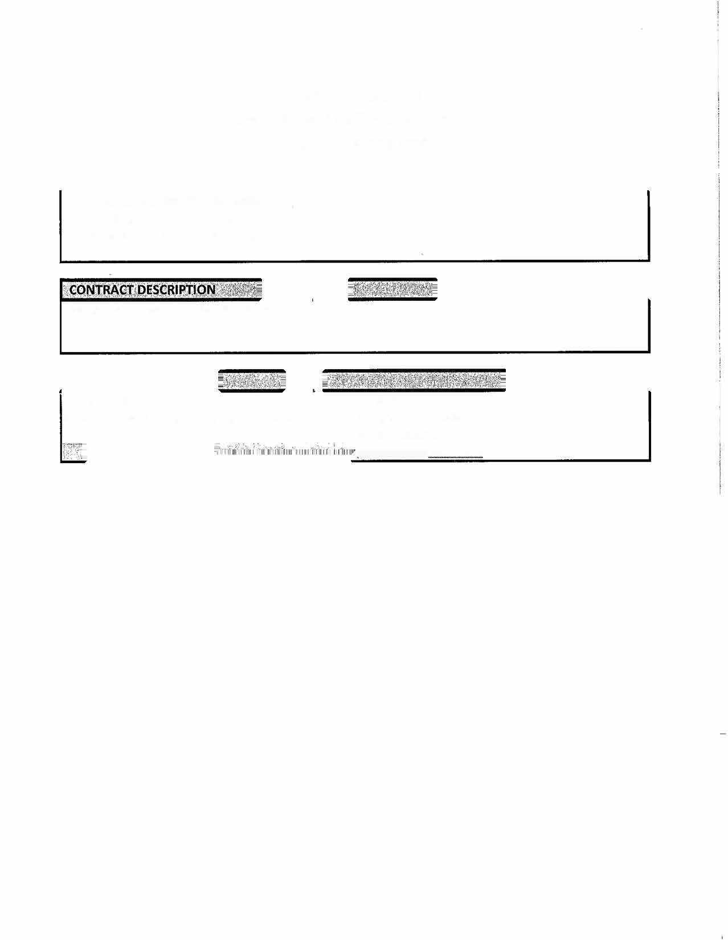


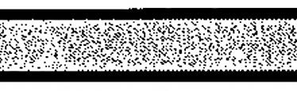


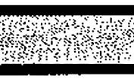


State of Alabama
Department of Transportation
Master Agreement
MASTER AGREEMENT NUMBER:
Begin Date:
/3/2026
6
Expiration Date:
6
/
2/2027

Montgomery Area High Intensity Mineral Bond
Name/Address:
25-001
Contact:
Douglas J. Alexander
Alexander Sealcoating & Striping VC000135235
334·264-4003

PO B
o
x 211032

Montgomery AL 36121

