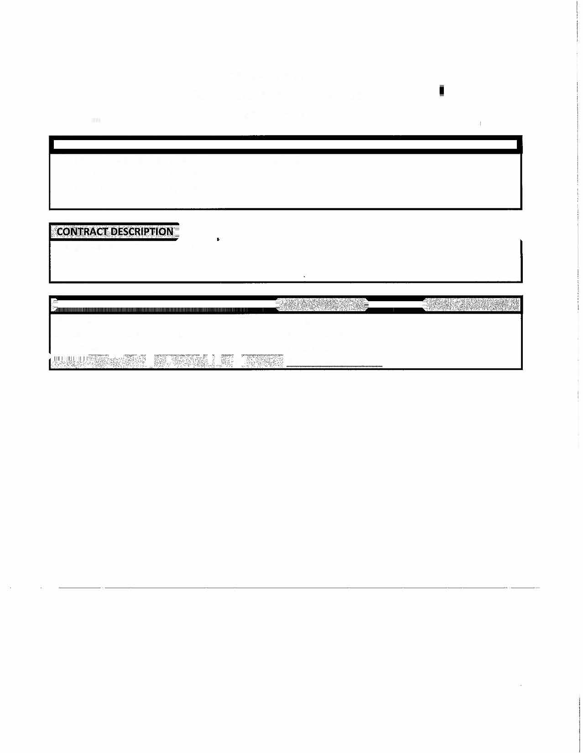

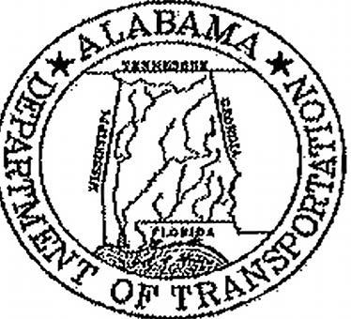

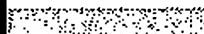

State of Alabama
Department of Transportation
Master Agreement
MASTER AGREEMENT NUMBER:
Begin Date:
6/3/2026
Expiration Date:
6
/2/2027
Montgomery Area Shoulder Treatment
Name/Address:
Asphalt Paving Systems VI000187050
609-
561-4161
25-002
Contact:
Robert Capoferri
PO Box 350
•

,

'
Hammonton NJ 08037
-
---- - -
-
--------------------------
----

