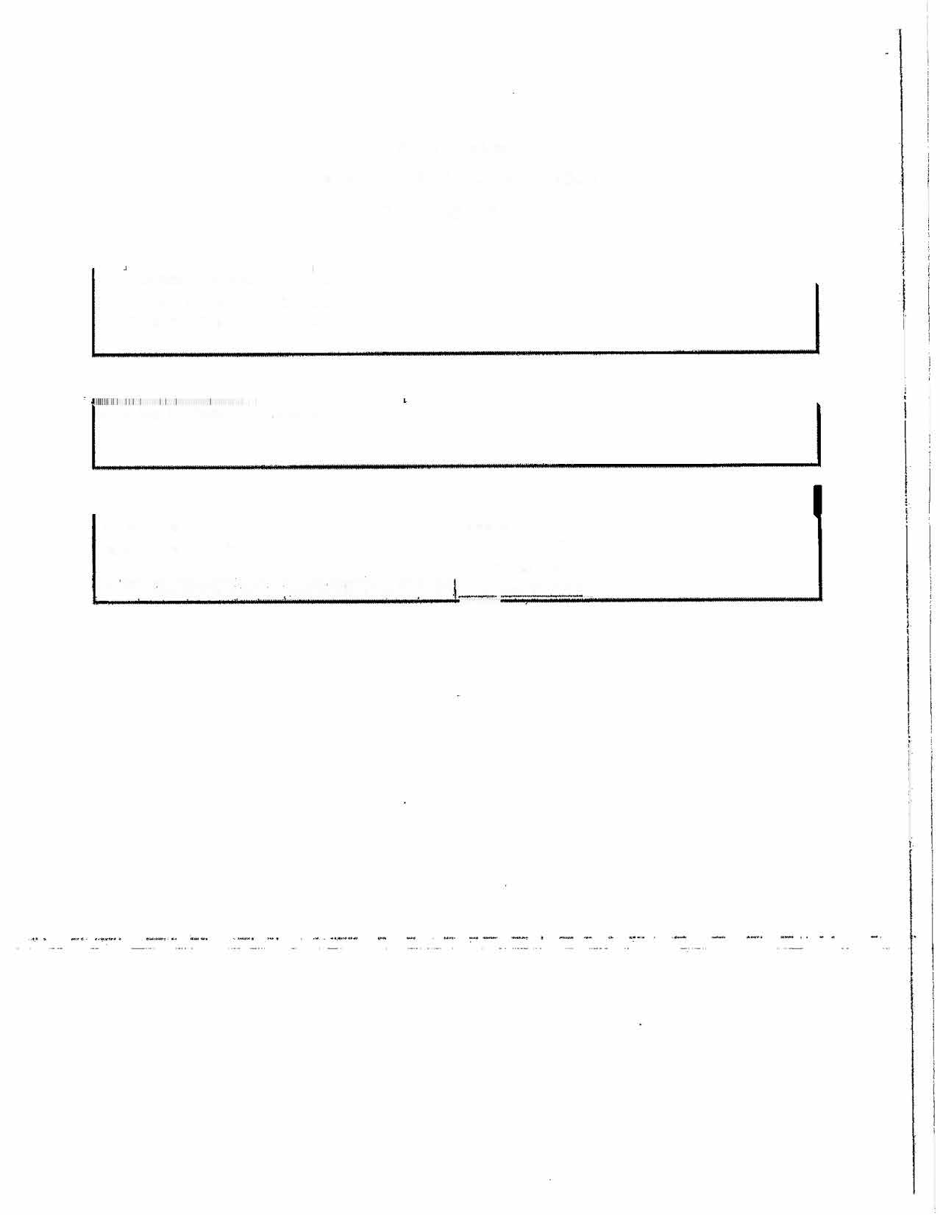


State of Alabama
Department of Transportation
Master Agreement
MASTER AGREEMENT NUMBER:
Begin Date:
6
/9/2026
Expiration Date:
6
/8/2027
Gulde Sign Fabrication/ Installation
Name/Address:
Contact:
Superior Traffic Control VS000064772
Adam Cooley VP

615-225-1075
Capital Way
114
'.?'•'r
!1'
'
1
.-
Christiana TN 37037

