Purpose:
The purpose of this TITB (Transportation Invitation to Bid) is to establish a Master Agreement for repair of guardrail and cable rail in the East Central Region – Birmingham Area. This Master Agreement will only be used by the Alabama Department of Transportation, through the Model Procurement Act.

Award:
This Master Agreement will be multiple awards to the three lowest bidders meeting the requirements of this specification. All line items must be bid on, or the bid will be deemed incomplete and thus rejected.

Mandatory Pre-Bid:
Contractors will be required to attend a mandatory on-site pre-bid meeting to be eligible to submit a bid.

Details for the mandatory pre-bid meeting are as follows:

Date: Wednesday, March 11, 2026
Time: 10:00 am (Central Time)
Location: ALDOT Birmingham Area Office Complex at 1020 Bankhead Highway West,
Birmingham, AL 35202. The meeting will be in the District 31 office conference room (see the google earth view below)
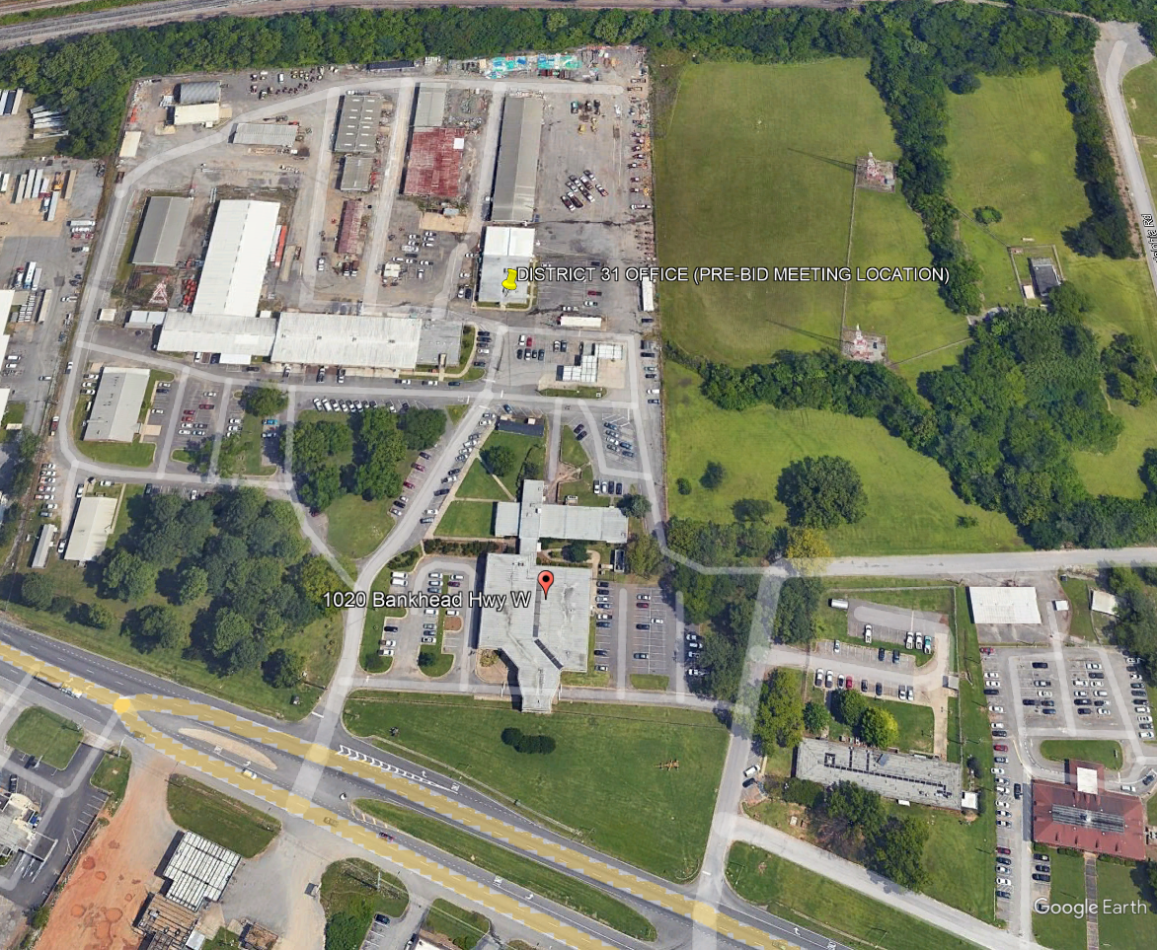

Bid submission instructions:
Bids must be submitted to bids@dot.state.al.us by 5:00pm on the “Expiration” date shown on the ALDOT Procurement of Supplies and Nonprofessional Services webpage. Link provided below.
https://www.dot.state.al.us/business/Procurementsupplies.html

Freight:

Freight pricing should be added to the bid when requested. Ordering location where merchandise is delivered and unloaded on a receiving dock, if available. The contract vendor is liable for risk or loss or damage to the merchandise up to the destination.

Delivery time frame:

All items ordered must be delivered to the “ship to” address shown on the Purchase Order within thirty (30) days of vendor’s receipt of order, unless previously agreed upon in writing by the ordering agency.

Materials:

All materials must be new, unused, and acceptable in accordance with this specification.

Contract period:
Establish a 12-month contract with an option to extend for a second, third, fourth, and fifth 12-month period with the same pricing, terms and conditions. The second, third, fourth, or fifth 12-month period, if agreed by both parties, would begin the day after the first, second, third, or fourth 12-month period expires. Any successive extension must have written approval of both the state and vendor no later than 30 days prior to expiration of the previous 12-month period.

Indemnity: Contractor shall be fully liable for the actions of its agents, employees, officers, partners, and Subcontractors, and shall fully indemnify, defend, and save harmless the Division, Eligible Users, and the State of Alabama from all claims, losses, suits, actions, damages, and costs of every name and description arising out of Contractor’s performance of this Contract caused by any intentional act or negligence of Contractor, its agents, employees, officers, partners, or Subcontractors, without limitation; provided, however, that the Contractor shall not indemnify for that portion of any claim, loss, or damage arising hereunder due to the sole fault of the Division, Eligible Users, or the State of Alabama. The parties agree that if there are any limitations of the Contractor’s liability, including a limitation of liability clause for anyone for whom the Contractor is responsible, such limitations of liability will not apply to injuries to persons, including death, or to damages to property.

Non-appropriation of funds:
Continuation of any agreement between the State and a bidder beyond a fiscal year is contingent upon continued legislative appropriation of funds for the purpose of this bid and any resulting agreement. Non-availability of funds at any time shall cause any agreement to become void and unenforceable and no liquidated damages shall accrue to the state as a result. The State will not incur liability beyond the payment of accrued agreement payment.

Proration:
Any provision of a contract resulting from this bid to the contrary notwithstanding, in the event of failure of the State to make payment hereunder as a result of partial unavailability, at the time such payment is due, of such sufficient revenues of the State to make such payment (proration of appropriated funds for the State having been declared by the governor pursuant to Section 41-4-90 of the Code of Alabama 1975), the contractor shall have the option, in addition to the other remedies of the contract, of renegotiating the contract (extending or changing payment terms or amounts) or terminating the contract.

Quantity:
The exact quantity of each item is unknown. The Department of Transportation does not guarantee the State will buy any amount. Orders will be placed by the agency as needed and they will be given complete shipping instructions.

Bid Requirement:
All bids must include the unit price for every line item. An awarded vendor may offer volume discounts for large quantity purchases.

Volume Discounts:
Volume Discounts are allowed with the provision that any purchasing entity that purchases the equivalent volume be offered the same discount. The State will not file for rebates; the vendor must offer and bill the net discounted price for any applicable offerings.

Price Escalation:

If, during the performance of this contract, the price of the material significantly increases, through no fault of the vendor, a price increase may be considered based upon product cost ONLY. Documentation of the price increase is required from the manufacturer. All price increases must be approved by both the state and the vendor in writing. Any de-escalation in price shall be passed onto the state immediately while still meeting all specifications, terms, and conditions of the contract.

Requested information:
Any additional information requested from a Contractor must be furnished within five (5) days from receipt of request.

Minimum Requirements:
Pursuant to Section 34-8-1 (a) of the Code of Alabama, each Contractor must submit with their bid proof of licensing through the Alabama State Board of Licensing for General Contractors, with approved maximum bid limits sufficient to cover the bid related to this specification. Failure to comply will be cause for rejection of the bid. A copy of the Contractor’s current year’s license will expedite the evaluation process.

Bidder must meet the requirements of Section 102 of the ALDOT Standard Specifications for Highway Construction, latest adopted edition. The provisions of Section 102.09 are waived for this Master Agreement. No bid bond is required. Each Contractor must submit with their quote proof of liability insurance in the minimum amount of $1,000,000.00 per occurrence, $2,000,000.00 aggregate. Each Contractor shall further provide proof of workman’s compensation insurance sufficient to satisfy all legal requirements of the State of Alabama. Failure to provide this documentation will the bid package will be cause for rejection of the bid.

Multiple Award Procedure:
The Alabama Department of Transportation (ALDOT) may, as it deems to be in the interest of the State and ALDOT, execute more than one Master Agreement based on this bid. The Contractor(s) understands and agree, by signature on the bid proposal this agreement does not constitute an exclusive Master Agreement for guardrail/cable rail repair services. ALDOT reserves the right to make multiple awards for the services provided through this bid if applicable. Furthermore, ALDOT reserves the right to reject all bids received.

Purchase Order assignment will be based on the lowest cumulative bid received. The Contractor with the lowest cumulative bid will be contacted first to perform the work determined by the District Administrator. The Contractor with the lowest cumulative bid must respond to the District Administrator with the anticipated start date, within three working days of notification unless noted otherwise. Failure on the part of the Contractor to reply within the specified time frame may be received as a rejection of the work. If the Contractor with the lowest cumulative bid cannot complete the work within the time specified in the assignment, the District Administrator may contact the Contractor with the next lowest cumulative bid. If that Contractor can complete the work within the time specified in the assignment, then the work will be assigned to that Contractor. If not, assignment of work will continue in the order of lowest cumulative bid until all awarded Contractors have had a chance to accept the terms of the work.

Contractor Requirements – General

The Contractor will be required to provide a warranty bond for each Purchase Order placed by ALDOT for the 12-month period covering the Master Agreement in the amount of $250,000.00. The value of the warranty bond must be equal to the Purchase Order amount. Each annual contract extension will require a renewal of the bond.

In accordance with Section 41-16-59 of the Code of Alabama, the successful bidder on this solicitation is restrained from assigning or sub-contracting any portion of the work under this Master Agreement.

Award will be made to multiple bidders meeting all specifications. Evaluation for award will be determined by the sum of the unit prices for all line items.

The contractor shall mobilize to each location they are required to perform work. There will be no direct pay for mobilization as it will be incidental to the other bid items. The only exception is if there is an emergency mobilization provision within the contract or if the Purchase Order is less than $20,000.

The contractor will be provided with a Purchase Order for each project with location(s), and quantities. Notifications will be verbal followed by an emailed approved Purchase Order. The Contractor will complete the work identified on each Purchase Order.
The Contractor will mobilize and complete the work within the time specified on the Purchase Order. Failure to complete the work by the completion date may result in the application of liquidated damages. Information concerning liquidated damage amounts and when they will apply are detailed in section 108.11 – prosecution and progress of the ALDOT standard specifications.

ALDOT Standard Specifications for Highway Construction will apply, as applicable, to the administration of this Master Agreement. All traffic control must be conducted in accordance with the Manual on Uniform Traffic Control Devices (MUTCD), latest adopted edition, and ALDOT’s Traffic Control Detail Library.

All guardrail repair work shall comply with the requirements outlined in the attached memo dated 5/21/18 regarding implementation of MASH standards.

Work Scope

The work will include the repair and replacement of guardrail and cable guardrail on an individual Purchase Order basis as determined by ALDOT. Each individual Purchase Order will be issued to the Contractor and must be completed in the time specified for that work order. Mobilization will apply if the purchase order is less than $20,000.

All workmanship must be of a professional quality and standard as generally accepted in the trade. All workmanship is subject to inspection and approval by the District Administrator, or his designee, and must meet the requirements of the ALDOT Standard Specifications (current edition) as well as any standard drawings, special drawings and special provisions.

Attention is drawn to the fact that this work will be performed under traffic conditions requiring special care to expedite the work and prevent undue hazardous conditions. Therefore, guardrail/cable rail repair operations will be performed between the hours of 8:00 PM and 5:00 AM, Sunday through Saturday, in the time frame specified in each individual purchase order, with the following exceptions:
- No work will be performed on national holidays or weekends on which a holiday falls on Monday or Friday.
- No work shall be done on weekends when the District Administrator expects a high volume of traffic.

Traffic control will be the responsibility of the Contractor in accordance with the Manual on Uniform Traffic Control Devices (MUTCD), latest adopted edition and chapter vi of the most current edition of the standards and guides for traffic controls for street and highway construction, maintenance, utility, and incidental management operations.

Bid prices to include all equipment, tools, labor and other necessary incidentals for the completion of this work in an approved and satisfactory manner. No work will be done without prior approval and notification by the District Administrator at locations designated.

The Contractor is also responsible for maintaining and controlling traffic and all other work as specified as part of this Master Agreement.

The Contractor must have a supervisor on the work site at all times to serve as his agent - a competent, English-speaking supervisor, thoroughly experienced in the type of work being performed. The supervisor’s main duties are to supervise the work crew(s), coordinate work with ALDOT inspectors, answer inquiries, investigate complaints, insure safe procedures, monitor traffic control devices, etc.. The supervisor is to serve as a worksite traffic control supervisor and be properly certified. Payment for supervision will be a subsidiary obligation of other pay items.

Performance Requirements:

The Contractor will be required to prosecute the work in a continuous and uninterrupted manner from the time they begin the work until completion and final acceptance of the Purchase Order. Multiple failures of the Contractor to mobilize and begin work on the Purchase Order within the agreed upon time frame or failure to complete the work within the given time frame may result in the Contractor being excluded from future work on the contract in accordance with this specification.

No operation will be conducted when there are climatic conditions present or forecast that would make such an operation ineffectual or dangerous. These climatic conditions include, but not limited to, heavy rain, fog, snow, ice, sleet and high winds.

Removal and proper disposal of damaged ALDOT assets (guardrail, cable rail, posts, channelizing drums, plastic waterfilled barrier, etc.) during the repair operation will be the responsibility of the Contractor. All applicable federal, state and local laws and ordinances related to the hauling, handling and disposition of such material must be complied with by the Contractor. The name, facility identification number, and location with proof that Contractor is using location for disposition of materials must be furnished to the ALDOT upon request. All landfill fees will be the responsibility of the Contractor.

The Contractor will provide uniform police officers they deem necessary to supplement their traffic control scheme and coordinate the scheduling of said officers.

Payment for the work will be made after the work is completed and approved.

An invoice is to be submitted to ALDOT once the work is completed.

The District Administrator has the authority to alter the work as he deems necessary. Any increases in quantities will be paid for at the unit bid prices.

Inspection

Inspectors for ALDOT must be provided by the District Administrator to see that the Contractor properly performs the work and maintains and controls traffic according to this specification for time and performance. Unsatisfactory areas must be addressed as directed by the District Administrator before beginning any new location.

Any deficiency in the Contractor’s performance will be reported to the Contractor after an inspection and/or completion of the work. Correction of deficiencies must be made no later than forty-eight (48) hours after notification.

The District Administrator will maintain a daily log of completed work and will verify the completion of the contractor’s work with the Contractor upon completion of the work associated with each Purchase Order.

Temporary Location Changes

In the event a road rehabilitation or improvement project is under construction or will be under construction where contract services are scheduled, that portion of the work may be temporarily deleted at the direction of the District Administrator. The section(s) of roads deleted from the list may be added back to the list at the first available opportunity following completion of said project.

Estimated Quantities

