Purpose:
The purpose of this TITB (Transportation Invitation to Bid) is to establish an unauthorized dumping and homeless encampment cleanup on call service Master Agreement (MA) for the East Central Region – Birmingham Area. This MA will only be used by the Alabama Department of Transportation, through the Model Procurement Act.

Award:
This MA will be single awarded to the bidder offering the lowest price for all line items.

Mandatory Pre-bid:
Contractors will be required to attend a mandatory on-site pre-bid meeting to be eligible to submit a bid.

Details for the mandatory pre-bid meeting are as follows:

Date: Wednesday, April 29, 2026
Time: 10:00 am (Central Time)
Location: ALDOT Birmingham Area Office Complex at 1020 Bankhead Highway West,
Birmingham, AL 35202. The meeting will be in the District 31 office conference room (see the google earth view below)
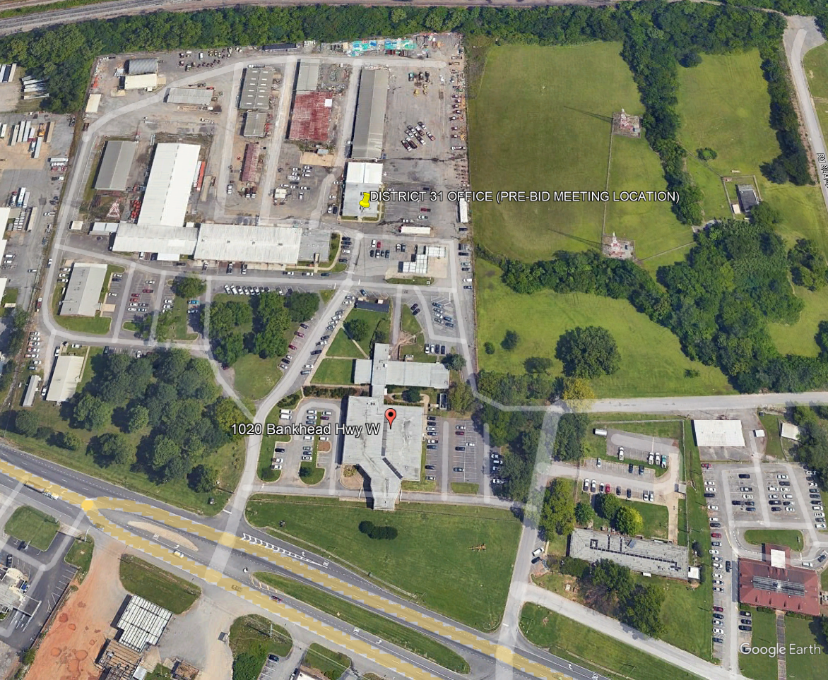

Bid submission instructions:
Bids must be submitted to bids@dot.state.al.us by 5:00pm on the “Expiration” date shown on the ALDOT Procurement of Supplies and Nonprofessional Services webpage. Link provided below.
https://www.dot.state.al.us/business/Procurementsupplies.html

Freight:

Not applicable.

Delivery time frame:

Not applicable.

Materials:

Not applicable.

Contract period:
Establish a 12-month contract with an option to extend for a second, third, fourth, and fifth 12-month period with the same pricing, terms and conditions. The second, third, fourth, or fifth 12-month period, if agreed by both parties, would begin the day after the first, second, third, or fourth 12-month period expires. Any successive extension must have written approval of both the state and vendor no later than 30 days prior to expiration of the previous 12-month period.

Indemnity: Contractor shall be fully liable for the actions of its agents, employees, officers, partners, and Subcontractors, and shall fully indemnify, defend, and save harmless the Division, Eligible Users, and the State of Alabama from all claims, losses, suits, actions, damages, and costs of every name and description arising out of Contractor’s performance of this Contract caused by any intentional act or negligence of Contractor, its agents, employees, officers, partners, or Subcontractors, without limitation; provided, however, that the Contractor shall not indemnify for that portion of any claim, loss, or damage arising hereunder due to the sole fault of the Division, Eligible Users, or the State of Alabama. The parties agree that if there are any limitations of the Contractor’s liability, including a limitation of liability clause for anyone for whom the Contractor is responsible, such limitations of liability will not apply to injuries to persons, including death, or to damages to property.

Non-appropriation of funds:
Continuation of any agreement between the State and a bidder beyond a fiscal year is contingent upon continued legislative appropriation of funds for the purpose of this bid and any resulting agreement. Non-availability of funds at any time shall cause any agreement to become void and unenforceable and no liquidated damages shall accrue to the state as a result. The State will not incur liability beyond the payment of accrued agreement payment.

Proration:
Any provision of a contract resulting from this bid to the contrary notwithstanding, in the event of failure of the State to make payment hereunder as a result of partial unavailability, at the time such payment is due, of such sufficient revenues of the State to make such payment (proration of appropriated funds for the State having been declared by the governor pursuant to Section 41-4-90 of the Code of Alabama 1975), the contractor shall have the option, in addition to the other remedies of the contract, of renegotiating the contract (extending or changing payment terms or amounts) or terminating the contract.

Quantity:
The exact quantity of each item is unknown. The Department of Transportation does not guarantee the State will buy any amount. Orders will be placed by the agency as needed and they will be given complete shipping instructions.

Bid Requirement:
All bids must include the unit price for every line item.

Volume Discounts:
Not Applicable.

Price Escalation:

If, during the performance of this contract, the price of the material significantly increases, through no fault of the vendor, a price increase may be considered based upon product cost ONLY. Documentation of the price increase is required from the manufacturer. All price increases must be approved by both the state and the vendor in writing. Any de-escalation in price shall be passed onto the state immediately while still meeting all specifications, terms, and conditions of the contract.

Requested information:
Any additional information requested from a vendor must be furnished within five (5) days from receipt of request.

Scope of Work
The State of Alabama Department of Transportation is seeking bids from qualified contractors to provide Unauthorized Dumping and Homeless Encampment Clean-Up Services. The purpose of this bid is to acquire a turnkey unauthorized dumpling and homeless encampment site cleanup for a safe and clean site by removing large items, biohazardous material and other unauthorized material within the State’s right-of way. The services required are on an on-call basis but would be scheduled with advance notice.

- General Requirements:

- As directed by the Alabama Department of Transportation, provide turnkey unauthorized dumping and homeless encampment site cleanup for a safe and clean site by removing large items, biohazardous material and other unauthorized material within the State right-of-way.

- Encampment Sites are considered to contain a variety of materials that may contain hazardous materials, including biohazardous materials, garbage, general debris, and other items which have been placed without authorization in the State’s right-of-way.

- Unauthorized Dumping Sites are considered to contain a variety of large items including furniture, appliances, motors, tires, construction debris, automobile parts, bicycles, mattresses, box springs, garbage, general debris, and other items which have been dumped without authorization in the State’s right-of-way.

- Sites will be identified individually. The Department of Transportation will try, when possible, to cluster several sites for assignment to the on-call service provider. Sites include but are not limited to under structures (e.g., bridges), open areas, vegetated ground cover, state-owned/maintained parks, in-road right-of-way, etc. Site locations may occasionally require confined space entry cleanup. The contractor will be required to coordinate all necessary permits as required.

- Site supervisor and worker(s) must be trained and certified in handling and disposal of hazardous materials and provide services in accordance with all state and federal laws. The contractor shall provide copies of any applicable training records, certifications, and licenses required to perform this work.

- The contractor must inspect the site prior to clean-up and confirm that sites are not occupied while the contractor is conducting the work.

- Other than mobilization, the contract will be paid based on hourly rates as shown in the line items on Attachment A. All other associated costs such, but not limited to equipment, fees, traffic control, etc. are a subsidiary obligation of other contract line items.

- Daily reports shall be submitted via email to the ALDOT District Administrator or his designee. The report is to include the following information at a minimum: date, equipment used, personnel used, location of the operation, and attached copies of all dump tickets showing the weight of debris removed.

- The contractor will be allowed to work Monday through Friday, from 8:00 am until 5:00 pm. On the rare occasion that a lane closure be required, they will only be allowed from 9:00 am until 3:30 pm. Any deviation from these work times must be approved by the ALDOT District Administrator or his designee.

- Traffic control if needed, will be the responsibility of the contractor in accordance with the Manual on Uniform Traffic Control Devices (MUTCD) and Chapter VI of the most current edition.

- Lane closures will require notification of the Regional Traffic Management Center (RTMC) via a traffic interruption reporting (TIR) form (see Attachment B).

- No work will be performed on the following days: New Year’s Day, Memorial Day, Independence Day, Labor Day, Thanksgiving Day, Christmas Day, or other days as determined by the ALDOT District Administrator. Work Orders (purchase orders from the MA) will consider these restrictions.

- Invoices for each purchase order shall contain a copy of the daily work reports associated with the invoice. The invoice shall be submitted once all operations have been completed to include demobilization.

2.0 Contractor Duties & Responsibilities:

- The Contractor shall coordinate with the State on a site-by-site basis to determine the work order for each site. The purchase order will establish the site start date, estimated timeframe of the work, staging areas, traffic control, if required, and the name of the onsite representative for the contractor.

- The Contractor shall provide a 5-day notice before work begins a site so that law enforcement personnel can address the relocation of Homeless individuals at the site.

- The contractor shall notify the ALDOT District Administrator or his designee if the site becomes occupied again prior to or during the work, or if an adjacent site is discovered in the general area during a project to obtain authorization prior to proceeding with any additional work that was not identified in the initial purchase order.

- Duties shall include inspection of sites to confirm they are not occupied prior to beginning clean-up, collecting debris and materials, dismantling temporary structures, removal of trash, removal of hazardous materials, and transport and disposal of all material. Disposal must be completed in accordance with all state and federal laws.

- The contractor shall supply all labor, material, tools, personal protective equipment (PPE), and equipment that is required or needed to perform the work to safely and effectively handle, remove, transport, and dispose of debris.

- The contractor shall provide all supervision and management of crews and subcontractors and ensure all necessary safety procedures are followed and that work is performed in a timely, courteous and business-like manner. Supervisors must be English speaking and able to fully communicate with ALDOT inspectors.

- The contractor shall photograph posted notices and the condition of the site prior to work and after work is completed and provide electronic copies of each photograph to the state.

- The contractor shall notify the State when the work is completed at a site and provide a clean-up report for each site, including all dump tickets showing the total weight of debris removed.

- The contractor shall stop working immediately if firearms, explosives, illegal contraband or human remains are present at the work site. Upon such a discovery all workers shall be vacated from the site followed by immediate notification of law enforcement and ALDOT.

3.0 ALDOT Responsibilities:

- ALDOT shall issue a purchase order and install notice to vacate signs at each site a minimum of 72 hours in advance of the start time of a clean-up project.

- The ALDOT District Administrator or his designee shall be the point of contact for reviewing work orders, authorizing work, inspecting work and addressing issues or questions.

- ALDOT will coordinate law enforcement and City efforts to remove inhabitants ahead of clean-up operations.

