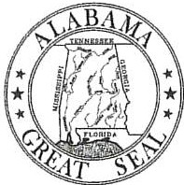
Kay Ivey Governor
ALABAMA DEPARTMENT OF TRANSPORTATION

John R. Cooper Transportation Director

May 4, 2026

TO:

FROM:

RE:
Ms. Fran Thomas
General Services Supervisor, Procurement

Jason Daniels, P.E.
State Traffic Engineer

Recommendation to Award -TITB #35 - Statewide Traffic Stripe, Marking, and RPM Installation Master Agreement

111e Maintenance Bureau has reviewed the Bid packets submitted in response to Transportation Invitation to Bid (TITB) # 35 - Statewide Traffic Stripe, Marking, and RPM Installation and recommends the multiple award as follows:

TRP Construction Group, LLC. Ozark Striping Company, LLC.
1st lowest bidder 2nd lowest bidder

The Maintenance Bureau recommends that the Master Agreement appear on the ALDOT's webpage for TITB Awarded Master Agreement Contracts, as shown below:

26-016

26-017
Statewide Traffic Strip, Marking, and RPM Installation -TRP Construction Group, LLC. (1) Statewide Traffic Strip, Marking, and RPM Installation - Ozark Striping Company, LLC. (2)

If further information is needed, please advise.

