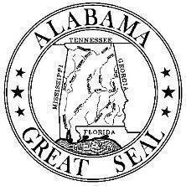 | Alabama Department Of Transportation  Construction Bureau  1409 Coliseum Boulevard, Montgomery, Alabama 36110  P.O. Box 303050, Montgomery, Alabama 36130-3050  Phone: (334) 242-6272 Fax: (334) 242-6378 | 
Kay Ivey |  | John R. Cooper
Governor |  | Transportation Director

April 24, 2026

NOTICE OF NEED FOR SERVICES

TO: Consultants

FROM: George H. Conner, P.E.
Deputy Director, Operations

RE: Project: Construction and Materials Management System (CAMMS)

The Alabama Department of Transportation is seeking professional services on the referenced project. Attached is a “Notice of Need for Services” containing the scope of work and evaluation items. Interested and qualified firms are being asked to submit their proposal for providing the products and services outlined herein. Firms responding must be fully capable of providing all documented end results. Following receipt of proposals, ALDOT will shortlist firms for further consideration.

This inquiry presents two distinct proposal options. Your response must be in the form of one or two proposals, submitted under separate cover, that address(es) the points listed in the evaluation portion of this Notice of Need for Services. Each proposed option must be limited to a maximum of thirty-five (35) pages not including appendices. If a vendor proposes both options, then two separate proposals, each with a maximum of thirty-five pages, must be submitted. Each vendor must submit the Proposal Cover Sheet with their submission(s) clearly indicating the option they are proposing along with contact information.

Failure to receive a response by the deadline indicated will be considered as “no interest.”

Table of Contents

- Scope of Services
- Two Optional Solutions
- Current System
- Access to CAMMS
- Minimum Mandatory Requirements
- Functional Requirements
- Proposal Content and Format
- Proposal Evaluation
- Schedule and Significant Dates
- ALDOT’s 2024 Request for Information

Attachment A – Functional and Technical Requirements
Attachment B – 2024 CAMMS RFI Narrative

Notice of Need for Services
Alabama Department of Transportation

Notice is hereby given that the Alabama Department of Transportation (ALDOT), Construction Bureau, 1409 Coliseum Boulevard, Montgomery, Alabama 36110, is requesting proposals from firms interested in performing the work outlined in the following scope of work.

SCOPE OF SERVICES

The Scope of Services to be provided by the vendor will include but not be limited to:

- Providing ALDOT with a new or updated Construction and Materials Management System (CAMMS) using one of the two options described in Section B as proposed by the vendor. The vendor will provide a Commercial-Off-The-Shelf (COTS) solution in a software-as-a-service (SaaS) system in a vendor-hosted environment with annual licensing and support for a ten-year period.
- Providing all necessary customization, configuration, interfaces and other implementation services needed to comply with the functional requirements for the proposed option. The vendor will be responsible for facilitating and managing the discovery tasks and implementation services needed to adapt the proposed solution to ALDOT’s business processes.
- Providing data conversion from ALDOT’s current CAMMS. ALDOT will be responsible for data quality assurance and control prior to the data conversion by the vendor. The vendor will develop and test the data conversion routines. ALDOT will work with the vendor to validate the post-conversion data.
- The vendor must determine integration with existing CAMMS data. Existing CAMMS data must be supported in the new system.
- If proposing a replacement option, the vendor must determine the best method for data migration from CAMMS to the new solution.
- Training ALDOT project team members and ALDOT’s inspectors, construction and materials management staff, consultants, and material producers on the proposed solution.
- Providing solution-specific training material for use by ALDOT staff, consultants, and material producers.
- Developing and testing any required customizations or configurations to meet mandatory requirements and facilitating ALDOT involvement in the testing process.
- Developing and testing required interfaces.
- System testing.
- Assisting with ALDOT’s planning and execution of user acceptance testing.
- Supporting a pilot implementation rollout if required by ALDOT.
- Leading production go-live and providing production support for up to six (6) months following go-live of the new system.
- Providing necessary project management services during the implementation effort.

TWO OPTIONAL SOLUTIONS

ALDOT will consider either of the options described below for implementing a new (full replacement) or updated (supplemental implementation) CAMMS. Vendors may submit proposals for either one of the options or for both. ALDOT is open to either a full replacement approach or a supplemental implementation approach. ALDOT’s inclusion of current-state system context and maturity is provided for transparency and sizing purposes only and should not be interpreted as a preference for either option. ALDOT’s selection will be based on the strength of the proposed solution for the option(s) submitted, including value, risk management, implementation approach, and ability to meet requirements.

If the vendor chooses to submit proposals for both options, the proposed solutions must be submitted as individual proposals, with each proposal limited to thirty-five pages. The scope of work will include all implementation and integration services necessary to deploy the vendor’s proposed solution, with the implementation and integration services tailored to the specific option proposed. A phased implementation of the selected vendor’s solution will be acceptable based on an agreed-upon schedule with ALDOT.

- Option 1 – Full Replacement. Replace ALDOT’s current CAMMS in its entirety, including both the construction and materials modules, with the vendor’s COTS solution in a vendor-hosted environment. The proposed solution must address ALL requirements in Attachment A.

- Option 2 – Supplemental Implementation. In this option, features of the current CAMMS system that meet the functional requirements contained in Attachment A will be left in place. The proposed solution must address ALL requirements in Attachment A, EXCEPT where Column D (Current CAMMS Function) is marked with a “Y”. The vendor will then supplement the current CAMMS with a solution to meet the remaining requirements not currently in CAMMS.

If the vendor proposes Option 2, ALDOT will continue to be responsible for those features of the solution that are currently supported by CAMMS within ALDOT’s current environment. The vendor will be responsible for supporting and maintaining those supplemental features of the solution that will be provided by the vendor’s software implementation.

Submitting only one option or submitting both will not disadvantage an offeror. Proposals will be evaluated solely on the merits of the option submitted and the offeror’s ability to meet the stated outcomes, requirements, and delivery approach for that option. If an offeror submits both options, each option must be submitted as a separate, complete response and each option will be scored independently. ALDOT will not average, blend, or otherwise combine scores across options.

ALDOT recognizes that offering multiple options can create internal pricing and approach tradeoffs for offerors. Offerors are encouraged to propose the option(s) they believe represents their strongest proposition for ALDOT.

CURRENT SYSTEM

CAMMS is an internally developed application that was first implemented in 2016. The Computer Services section of ALDOT developed the system according to requirements provided by personnel from ALDOT construction offices, materials labs, project field offices, accounting, and the State Office Engineer, and Computer Services provides technical support and upgrades to CAMMS based on requests from the Construction Bureau and Bureau of Materials and Tests. CAMMS currently functions to support ALDOT processes and procedures, and any proposed solution would need to preserve these processes and procedures.

The CAMMS technical environment is as follows:

- The legacy portion of the system runs in Internet Information Services (IIS). Modern components are not currently part of the production environment or testing environments.
- CAMMS uses C#, JavaScript, jQuery, ADO.NET, and the .NET Framework, with SQL Server as the database platform. Database logic is written in T-SQL for stored procedures and functions. Reporting is produced using Active Reports and SSRS. Azure Blob Storage is used for file and document storage.
  - A CAMMS Web Application Programming Interface (API) exists for internal use because no external endpoints are exposed for use by other systems. It is currently only utilized by a few processes.
- CAMMS key interfaces include: Human Capital Management (HCM; in-house system), Comprehensive Project Management System (CPMS; in-house system), AASHTOWare Project (AWP), Geographic Information System (GIS), and the Asphalt/Fuel Index tool.
- Vendors can be granted access to the existing CAMMS environment, with some lead time required for preparation.

CAMMS supports two major construction management functions for ALDOT:

- Construction contract management and administration
- Materials Sampling and Testing

CAMMS provides about 70 percent of ALDOT’s desired functionality for construction management and administration. The materials and testing functionality is considerably less mature and currently provides about 40 percent of ALDOT’s desired functionality.

ALDOT’s construction program includes an average of 229 projects awarded annually, with an average annual total contract value of approximately $800.6 million. As of October 2025, ALDOT’s portfolio contains 291 active projects, with 6,566 distinct projects loaded in the CAMMS system to date.

- ACCESS to CAMMS
Vendors will have access to ALDOT’s CAMMS while preparing their proposals. The access period will open from the issue date of this RFP until the day that the proposals are due. To gain access to CAMMS please submit an application at:

https://www.dot.state.al.us/publications/Construction/pdf/CAMMS/CAMMSAccessForm.pdf

CAMMS access also requires signing a Non-Disclosure Agreement (NDA) located here:

https://www.dot.state.al.us/publications/Construction/pdf/CAMMS/CAMMS_NDA.pdf

MINIMUM MANDATORY REQUIREMENTS

To be considered responsive to this notice of Notice of Need for Services, a vendor MUST demonstrate the following:
- The vendor’s proposed solution, for each option proposed by the vendor, must be a commercially available software application.
- The vendor software must have been successfully implemented for two (2) public agencies of similar size and scope as ALDOT.
- The proposer must provide reference letters from the two public agencies noted above.
- The proposer must be able to provide software as a service (SaaS) pricing for a total of ten (10) years from date of project initiation.
- The proposed solution must have a mobile component that can be used by field staff through phone, tablet, and laptop-based interfaces, at a minimum for Apple iOS and Android platforms.
- The proposed solution must support bidirectional integration with ALDOT’s geographic information system (GIS) data from both ALDOT and external sources along with other existing business systems as needed.
- The proposer must provide an implementation plan that includes the level of effort necessary for ALDOT staff.

FUNCTIONAL REQUIREMENTS

The Functional and Technical Requirements Matrix (Attachment A) shows which requirements are currently met by ALDOT’s existing CAMMS. If the vendor chooses to submit a proposal for Option 2, the vendor’s proposed solution must meet those requirements in Attachment A that ARE NOT currently met by the existing CAMMS.

PROPOSAL CONTENT AND FORMAT

IF THE VENDOR SUBMITS PROPOSALS FOR BOTH OF THE OPTIONS DESCRIBED IN SECTION B, THE VENDOR MUST SUBMIT A SEPARATE PROPOSAL FOR EACH OPTION. Proposals, for either option 1 or 2, must address the topics ordered in the sequence shown in Figure 1.
Figure 1 - Proposal Format

      - Proposal Cover Sheet
      - Understanding of the Project and Need
      - Overview of the Proposed Team and Project Experience
      - Implementation Approach and Capability, addressing the Scope of Services
described in Section A
      - Capability of Proposed Solution
      - Assumptions
      - *Appendix A – Response to Functional and Technical Requirements
(Attachment A), for the proposed option
      - *Appendix B – Resumes
      - *Appendix C – Reference Letters
      - *Appendix D – Vendor’s standard Service Level Agreement
*NOTE: Sections marked with an asterisk DO NOT count toward the 35-page limit

- Proposal Cover Sheet
Include the following information on the proposal Cover Sheet:
- Vendor name.
- Option contained in the proposal. Two proposals are required if a firm is proposing both options.
- Contact person’s name, title, and email address.

- Understanding of the project and ALDOT’s need
  - Provide an overview of your understanding of construction and materials management in a DOT, and associated best practices, as it relates to ALDOT’s requirements.
  - Describe why your firm is best suited for ALDOT’s proposed effort.
  - Demonstrate experience with DOTs or similar agencies.

- Overview of the proposed team and project experience
  - Firm and team
    - Provide a profile of the company, including years in business, office locations, number of employees, proposed project team, and experience.
    - Identify any/all subcontractors that may be used on this project and the expertise/capability they will provide.
    - Explain if the proposer is the owner of the software being proposed or a legally authorized distributor.
    - Provide an organizational chart for the proposed project team.
    - Identify proposed key personnel and describe their roles on this project. Align experience for each team member with their proposed role. At a minimum, this must include Project Manager, Senior Subject Matter Experts, IT Developers, and Training Lead.
    - Provide the availability of the proposed key team members for the duration of the proposed schedule.
    - Resumes for key team members can be provided separately and must be limited to two (2) pages. Resumes will not count against the page limit and can be provided as Appendix B.
  - Experience
    - Provide a minimum of two (2) reference projects for public agencies with similar size and scope to this proposed effort, as noted under Mandatory Minimum Requirements, number 2.
    - Provide reference letters for the two (2) reference projects above. Reference letters do not count against the thirty-five (35) page limit and can be provided as Appendix C. Reference letters must include:
      - Proposer’s Project Manager, client name, location, year, and project duration.
      - Project description as it relates to the proposed effort.

- Implementation approach and capability
Proposed Solution
  - For Option 1, provide an overall description of the proposed software solution. Complete the Functional and Technical Requirements (Attachment A of this RFP) and include your responses as Appendix A of your Option 1 proposal.
  - For Option 2, describe the strategy you are proposing to achieve a blend of the current CAMMS construction and materials and tests modules with the vendor’s software solution. Complete the Functional and Technical Requirements (Attachment A of this RFP) and include your responses as Appendix A of your Option 2 proposal.
  - For the option you are proposing, clearly explain why the proposed option is the best fit for ALDOT.

Implementation Approach
  - Explain your project management methodology for implementation of the software and provide a proposed timeline of the implementation processes and schedule. Identify the duration of each task.
  - Provide a description of your firm’s quality assurance/quality control (QA/QC) processes and project management approach.
  - Describe your approach to solution discovery and implementation efforts.
  - Describe your proposed training methodology.
  - Describe your data conversion process from existing business systems to the proposed software solution. As described above, ALDOT will be responsible for data clean-up prior to the vendor migrating the data to the new system.
  - Describe your transition approach – how will ALDOT switch over to the new system?
  - Describe the expected ALDOT involvement and potential level of effort.
  - Enterprise technology standards
    - Describe your SaaS approach.
    - Describe your disaster recovery plan.
    - Provide your standard Service Level Agreement (SLA) as Appendix D with your proposal. The SLA will not count against the page total.

- Capability of proposed solution
  - Discuss how your proposed solution can effectively meet ALDOT’s functional and technical requirements.
  - Demonstrate that your software solution has been sufficiently developed and will meet ALDOT’s requirements.
  - Discuss which functions of the solution are currently in production versus development.
  - Describe the configurability of your proposed solution.
  - Provide additional details on your ability to meet “mandatory” requirements compared to “important” or “desirable” as defined in Attachment A this RFP.
  - Detail your technology platform.
  - Describe any value-added functionality.

- Assumptions
  - Proposer must explicitly list all, if any, assumptions made that are believed to be necessary to respond to this proposal.

Proposals MUST NOT exceed thirty-five (35) 8.5 x 11” pages using standard fonts and spacing and must be submitted as an email attachment in Portable Document Format (PDF).

Responses to the requirements of this RFP (Attachment A) must be submitted as Appendix A of your proposal. The Appendix does not count against the page limit.

Offerors and their agents may not contact any other state employee regarding these matters during the solicitation and evaluation process. Inappropriate contacts are grounds for suspension or exclusion from specific procurements.

PROPOSAL EVALUATION

Proposals will be evaluated in two phases. Phase 1 will focus on a review of each firm’s technical response submitted by their proposal, with scores as outlined in Figure 2. A total of 1,000 points are possible for Phase 1 according to the following table.

Figure 2 - Proposal Evaluation Criteria and Scoring

Phase 1: Detailed Technical Response (1000 Total Points Possible)
EVALUATION CRITERIA | Points
1. Understanding and Experience (150 points)
Clear grasp of ALDOT construction and materials management and best practices | 100
Demonstrated experience with DOTs or similar public agencies | 25
Reference letters from a minimum of two projects | 25
2. Team Structure and Personnel (125 points)
Roles and credentials of key personnel on project team | 75
Recent successes on similarly scoped project experiences | 50
3. Firm's Implementation Capability (225 points)
Implementation approach | 100
Project and change management approach | 75
QA/QC and Testing plan | 50
4. Solution's Capability (500 points)
Ability to meet mandatory requirements out of the box or with configuration | 300
Ability to interact/interface with ALDOT key systems | 125
Querying and reporting capabilities | 75

Phase 2: Based on ALDOT’s evaluation of the technical responses and discretion, select vendors will be invited to provide a scripted demonstration of their proposed solution and implementation approach leveraging sample data provided by ALDOT. There is no minimum Phase 1 score for a vendor to be included in the shortlist. We anticipate the shortlisted proposer’s demonstration will last 2-3 days. Final technical evaluation criteria for the short-listed firms will be provided at the beginning of the Phase 2 evaluation process.

Cost proposals are only due from offerors that are short-listed. Short-listed proposers will receive a notification of being short-listed and will be given instructions for submitting their cost proposal at that time. Cost proposals will be evaluated in conjunction with the in-person demonstration: the total points allocated to Phase 2 is an aggregate 1,000 points, as shown in Figure 3, with in-person demonstrations representing 800 possible points, and cost proposals representing 200 possible points.

The price points assigned to each offeror's cost proposal will be based on the lowest proposal price. The offeror with the lowest proposed price will receive 100% of the price points (200 points). All other offerors will receive a portion of the total price points based on what percentage their Proposed Price is greater than the Lowest Proposed Price. For example:

Lowest Price = $1,000,000. Proposer A Price = $1,500,000
Using the formula: Proposer’s Price Points = Lowest Proposed Price/Proposer A Price * 200
With this formula Proposer A receives 1,000,000/1,500,000 * 200 = 133 points

ALDOT reserves the right to evaluate price proposals to determine the reasonableness of cost. Should ALDOT determine a price proposal is unreasonable, ALDOT reserves the right to request revised price proposals from short-listed vendors.

When pricing information is provided, it must delineate the total upfront and ongoing costs. Ongoing support and subscription costs must be projected out for ten (10) years from project initiation. Items such as, but not limited to, configuration and customization, license and subscription, new report/query/form configuration, consulting, support, on-call, access, hosting, and third-party costs, must be included.

Figure 3 - Phase 2 Evaluation and Scoring
Phase 2: Short-Listed Vendor Demonstration and Cost
(1000 Total Points Possible)
EVALUATION CRITERIA | Points
1. Short-Listed Vendor Demonstration (800 points) | 800
2. Cost (200 points) | 200

SCHEDULE AND SIGNIFICANT DATES

The schedule set out in Figure 4 represents the State’s best estimate of the schedule that will be followed. All the times indicated are at Central Time. If no time is indicated, it is understood to be 4:00 PM CDT. If a component of this schedule is delayed, the rest of the schedule will likely be shifted.

Figure 4 - RFP Schedule
RFP Release | April 24, 2026
Mandatory CAMMS Demonstration | May 5-7, 2026
Mandatory Pre-Proposal Conference | May 13, 2026 at 3:00 PM
CAMMS Review Period for Vendors | May 14 - June 4, 2026
Q&A session with interested vendors (one hour) | May 27-29, 2026
Deadline to Submit Questions | June 5, 2026
Official Responses to Questions Posted | June 12, 2026
Proposals Due | June 26, 2026
Evaluation of Proposals | July 6-24, 2026
Short-listed Firms Demonstrations & Evaluations | September 21 - October 9, 2026
Anticipated Notice of Selection | October 26-30, 2026

For vendors who did not attend the initial pre-proposal conference on January 20, 2026, a mandatory, in person, pre-proposal conference is scheduled for May 13, 2026, at 3:00 PM CDT at the SER-Montgomery Area Training Facility, 660 Chisholm St., Montgomery, AL 36110.

For vendors who attended the initial pre-proposal conference on January 20, 2026, remote or in-person attendance is required on the date above.

Attendance according to the stipulations above is mandatory for proposers wishing to respond to this Notice of Need for Services, and proposals will be rejected from vendors not in attendance.

_______________________________________________________________________

“It is the policy of the Alabama Department of Transportation that Disadvantaged Business Enterprises as defined in 49 CFR Part 26 shall have the maximum opportunity to participate in the performance of contracts financed in whole or in part with Federal funds.

Firms selected for work by the Alabama Department of Transportation agree to ensure that Disadvantaged Business Enterprises as defined in 49 CFR Part 26 have the maximum opportunity to participate in the performance of work associated with this project. We expect that all necessary and reasonable steps be taken to ensure that Disadvantaged Business Enterprises have the maximum opportunity to perform contract work.”

- ALDOT’S 2024 REQUEST FOR INFORMATION

In 2024, ALDOT issued a Request for Information (RFI) to obtain information from prospective vendors to help the Department determine the best and most cost-effective strategy for achieving its construction management objectives. The RFI is included in Attachment B for information only.

Attachment B – CAMMS RFI Narrative (2024)

Dye Management Group
Alabama Department of Transportation
Construction and Materials Management System
Request for Information - RFI

The Alabama Department of Transportation (ALDOT or Department) is undertaking an initiative to improve its construction management system and is looking at two options:
- Enhance its current Construction and Materials Management System (CAMMS) by adding critical new functionality. The added functionality would be achieved by incorporating select modules or features from a Commercial Off-the-Shelf (COTS) solution to be integrated into and seamlessly interface with CAMMS.

- Replace CAMMS entirely with a highly-configurable COTS solution, preferably in a Software-as-a-Service (SaaS) environment.

The purpose of this RFI is to obtain information from prospective vendors to help the Department determine the best and most cost-effective strategy for achieving its construction management objectives.
Dye Management Group, Inc. (DMG) is assisting ALDOT with its improvement initiative. This is an informal RFI issued by DMG to gather information on the cost, level of effort, and schedule for each of the two options. You are receiving this RFI because you indicated in previous correspondence, either with ALDOT or DMG, that you would be willing to provide information on how you could help ALDOT achieve its improvement objectives. Should the Department choose to proceed with either of the two options, a formal procurement process will be conducted.

CAMMS Background
CAMMS is an internally developed application first implemented in 2016. The Computer Services section of ALDOT developed the system and provides technical support and upgrades to CAMMS based on requests from the Construction and Materials and Testing Bureaus.

The CAMMS technical environment is as follows:

- The legacy portion of the app runs in IIS with current portions running in Kubernetes
- CAMMS uses c#, JavaScript, PL/SQL, T-SQL, .NET core, .NET framework. The database has been migrated from Oracle to SQL Server*. The app produces reports in Active Reports and SSRS.
  - Note: The migration to SQL Server was completed after the RFI was released.
- CAMMS key interfaces include: AASHTOWare Project (AWP), Human Capital Management (HCM), Comprehensive Project Management System (CPMS), Geographic Information System (GIS), Asphalt/Fuel Index.

CAMMS supports two major construction management functions for ALDOT:

- Construction contract management and administration
- Materials and Testing (M&T)

CAMMS provides about seventy (70) percent of ALDOT’s desired functionality for construction management. The M&T functionality is considerably less mature and provides about forty (40) percent of ALDOT’s desired functionality.

How Your Information Will Be Used
DMG will hold the information received from vendors in strict confidence. DMG will use the information to advise ALDOT on a recommended best strategy. DMG will not attribute any information received to an identified source. Because this is an information gathering exercise and the request is from DMG, it is not subject to Alabama procurement practices and is not public information.

Information Requested from Vendors
The functional and technical requirements for each of the two options are included as attachments. DMG is requesting the following information for each of the two options:

- An estimated cost to provide the desired functionality
- Identify the services you would include, such as: development/customization, training, user manuals, post-implementation support, etc.
- An estimated number of months to develop and implement the options
- An estimated number of person-months to implement each option
- A description of the resources or staffing commitment you would expect from ALDOT
- For each option, identify the critical technical challenges and risks

Please complete the following RFI response table and return via email by to:

Rob Zilay, President
Dye Management Group, Inc.
rzilay@dyemanagement.com

On behalf of ALDOT, thank you for helping the Department evaluate the best path forward for its construction management improvement initiative.
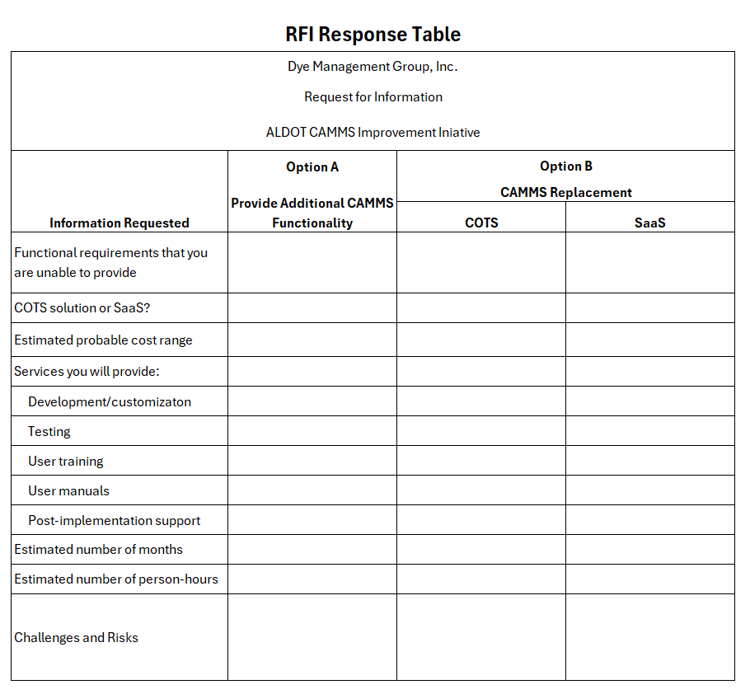

As amended by Disadvantaged Business Enterprise Program and Disadvantaged Business Enterprise in Airport Concessions Program Implementation Modifications, 90 FR 47969 (Oct. 3, 2025).

