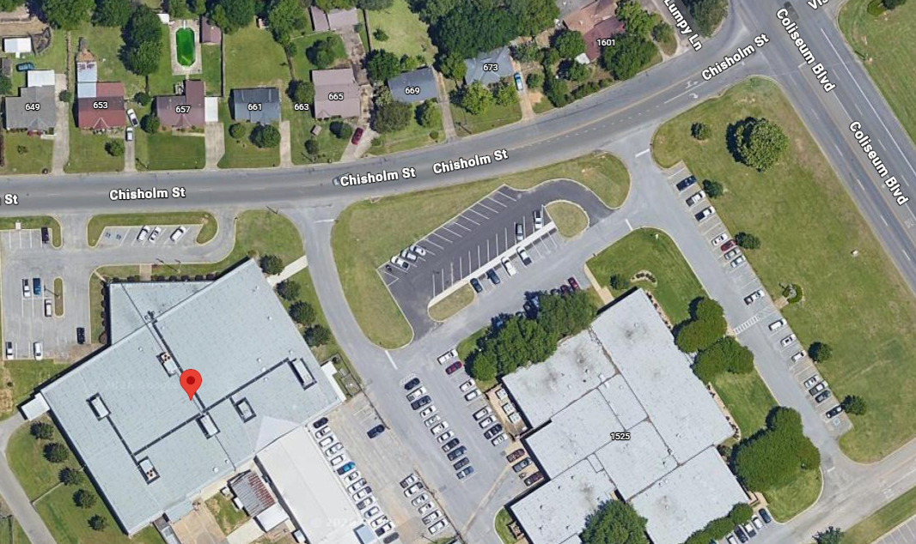

- Address: 660 Chisholm Street, Montgomery, AL 36110
- Enter at the side of building (see red arrow). There is a sign that says “SER-MONTGOMERY AREA TRAINING FACILITY” above the door.
- Park in the areas indicated above.

