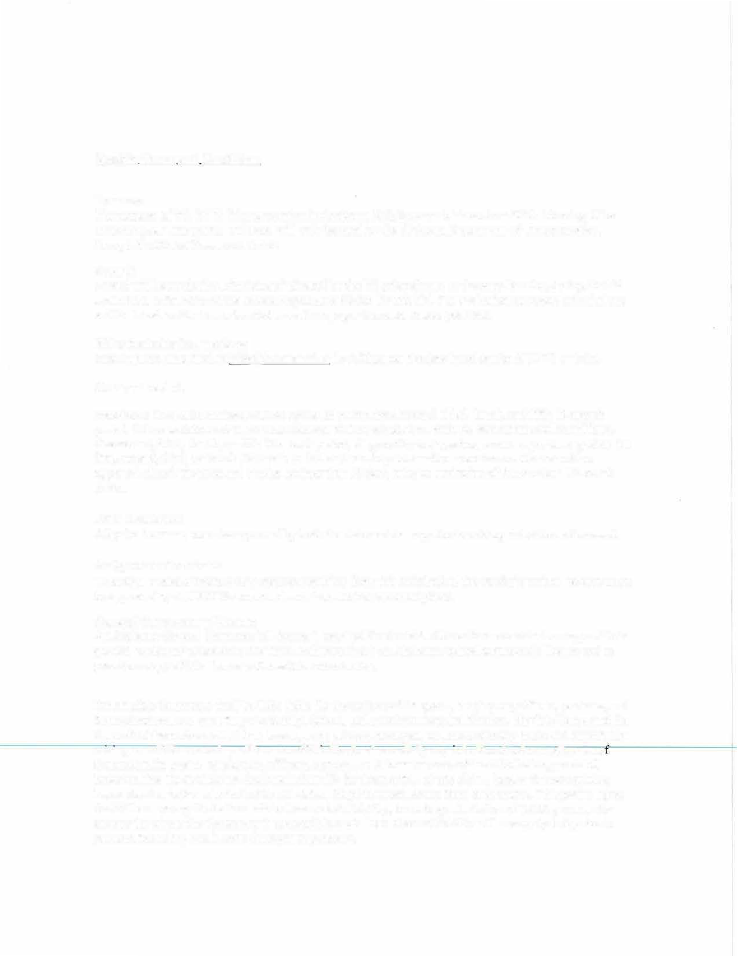
TITB Mowing and Litter Pickup MA for District 72 (Coffee, Geneva, and Dale County) Bid # 44

Specific Terms and Conditions

Purpose:
The purpose of this TITB (Transportation Invitation to Bid) is to establish a District Wide Mowing and Litter Pickup (MA) for District 72. This MA will only be used by the Alabama Department of Transportation, through the Model Procurement Act.

Award:
Award will be made to the supplier who, during the bid evaluation, is found to be the lowest responsible bidder for this bid. For evaluation purposes, calculations will be based on the total estimated annual usage per the route sheets provided.

Bid submission instructions:
Bids must be submitted to bids@dot.state.al.us by 5:00pm on the date listed on the ALDOT website.

Contract period:
Establish a 12-month contract with an option to extend for a second, third, fourth, and fifth 12-month period. Price escalations at the time of renewal will be considered. with the same terms and conditions. The second, third, fourth, or fifth 12-month period, if agreed by both parties, would begin the day after the first, second, third, or fourth 12-month period expires. Any successive extension must have written approval of both the state and vendor no later than 30 days prior to expiration of the previous 12-month period.

Price Escalation:
All price increases must be approved by both the state and the supplier in writing at the time of renewal.

Assignment of contract:
To assign, sublet or transfer any contract resulting from this solicitation, the vendor's written request must be approved by ALDOT Procurement and Area Maintenance Engineer.

General Contractor's License:
An Alabama General Contractor's License is required for this bid. All vendors must attach a copy of their general contractor's license to the TITB. Failure to have an Alabama general contractor's license and to provide a copy of this license will result in bid rejection.

Indemnity: Contractor shall be fully liable for the actions of its agents, employees, officers, partners, and Subcontractors, and shall fully indemnify, defend, and save harmless the Division, Eligible Users, and the State of Alabama from all claims, losses, suits, actions, damages, and costs of every name and description arising out of Contractor's performance of this Contract caused by any intentional act or negligence o Contractor, its agents, employees, officers, partners, or Subcontractors, without limitation; provided, however, that the Contractor shall not indemnify for that portion of any claim, loss, or damage arising hereunder due to the sole fault of the Division, Eligible Users, or the State of Alabama. The parties agree that if there are any limitations of the Contractor's liability, including a limitation of liability clause for anyone for whom the Contractor is responsible, such limitations of liability will not apply to injuries to persons, including death, or to damages to property.

Non-appropriation of funds:
Continuation of any agreement between the State and a bidder beyond a fiscal year is contingent upon continued legislative appropriation of funds for the purpose of this bid and any resulting agreement. Non-availability of funds at any time shall cause any agreement to become void and unenforceable and no liquidated damages shall accrue to the state as a result. The State will not incur liability beyond the payment of accrued agreement payment.

Proration:
Any provision of a contract resulting from this bid to the contrary notwithstanding, in the event of failure of the State to make payment hereunder as a result of partial unavailability, at the time such payment is due, of such sufficient revenues of the State to make such payment (proration of appropriated funds for the State having been declared by the governor pursuant to Section 41-4-90 of the Code of Alabama 1975), the contractor shall have the option, in addition to the other remedies of the contract, of renegotiating the contract (extending or changing payment terms or amounts) or terminating the contract.
Quantity:
The exact quantity of each item is unknown. The Department of Transportation does not guarantee the State will buy any amount. Orders will be placed by the agency as needed and they will be given complete shipping instructions.

Quality of materials and labor:
Materials used that are not otherwise specified shall be the kind and quality consistent with the trade practice for such work and shall comply with all local codes. All labor shall be well experienced in this type work and it shall be completed in a professional manner.

Requested information:
Any additional information requested from a vendor must be furnished within five (5) days from receipt of request.

Liability Insurance:
The vendor must have a minimum of $2,000,000.00 liability coverage with $1,000,000.00 per occurrence and must be in effect for the contract period. An insurance certificate, or letter of intent to provide the amount of coverage from the insurance company must be submitted with the bid, or the bid will be rejected. The vendor is responsible for all losses/damages caused by its employees. Insurance certificate, when issued, must show the State of Alabama as the certificate holder.
Vendor must have workman's compensation insurance in accordance with the laws of the state of Alabama and furnish proof of insurance with the bid.

