ALABAMA DEPARTMENT OF TRANSPORTATION
Design Bureau Traffic & Safety Operations

Rail-Highway Safety Programs Group
1409 Coliseum Boulevard, Montgomery, Alabama 36110

Railroad Crossing Warning Device Checklist for
Construction Projects with Railroad Involvement

The following checklist is a guide to determine the condition and compliance of existing rail-highway traffic control devices or crossings when a crossing is located within or near the terminus of a project. This checklist is developed in accordance to the regulations listed in Title 23 CFR 646.214 (b)(3)(i), MUTCD, other Federal and State guidelines. The included MUTCD references are provided in this checklist for quick reference, reference Part 8 of the current MUTCD guide for additional information, detail, and options.
*REQUIRED
*PROJECT NUMBER |  |  | *DATE SUBMITTED  Click or tap to enter a date.
*STREET/ROAD NAME (INCLUDE COUNTY/STATE/U.S. ROUTE) |  |  | *CROSSING INVENTORY NUMBER (i.e. 123456A)
*COUNTY | CITY/TOWN (IN OR NEAR) |  | LETTING DATE  Click or tap to enter a date.
 | POSTED HIGHWAY SPEED (MPH) |  | *Annual Average Daily Traffic (AADT) & YEAR
*SCOPE OF WORK AT CROSSING:

KNOWN IMAPCTS TO COMMUNITY i.e. RESIDENTIAL OR COMMERCIAL DEVELOPMENT, EMERGENCY VEHICLE ACCESS ROUTE, HAZARD MATERIAL ROUTE, SCHOOL BUS ROUTE, BLOCKED CROSSING, HUMPED CROSSING, ETC. (IF APPLICABLE, PROVIDE DOCUMENTATION):

CLASSIFICATION INFORMATION
*cROSSING TYPE  Choose an item. | *CROSSING PURPOSE  Choose an item. | *CROSING POSITION  Choose an item. |  | tYPE OF LAND USED  Choose an item.
*nUMBER OF TRAFFIC LANES CROSSING RAILROAD  Choose an item. | *Highway System  Choose an item. | *Functional Classification of Road at Crossing  Choose an item.  Choose an item.
*Emergency Service Route  Choose an item. | *School Bus Route  Choose an item. | *Transit Bus Route  Choose an item. |  |  | *estimated percent trucks %
Smallest Crossing Angle  Choose an item. | - Is Roadway/Pathway Paved? Choose an item.  - Does Track Run Down a Street? Choose an item.  - Is Crossing Illuminated? (Lights within approx. 50 feet from nearest rail) Choose an item.  - Intersecting Roadway within 500 feet? Approx. distance (feet)  - Is there an adjacent crossing with a separate number? DOT No(s).

Preliminary Document Not for Release pursuant to 23 U.S.C. §§130 and 148 and other federal safety programs and is exempt from discovery or admission under 23 U.S.C. §§ 402 and 409.

EXISTING CROSSING EQUIPMENT AND SITE CONDITIONS (Passive Warning devices)
(Specify the count of each device for all that apply i.e. Count or ____)
*Advance Warning Signs
Approach | Sign | Condition
Choose an item. | Choose an item. | Choose an item.
Choose an item. | Choose an item. | Choose an item.
Choose an item. | Choose an item. | Choose an item.
Choose an item. | Choose an item. | Choose an item.
Choose an item. | Choose an item. | Choose an item.
Choose an item. | Choose an item. | Choose an item.
*Pavement Markings
Approach | TYPE | Condition
Choose an item. | Choose an item. | Choose an item.
Choose an item. | Choose an item. | Choose an item.
Choose an item. | Choose an item. | Choose an item.
Choose an item. | Choose an item. | Choose an item.
Channelization Devices/Medians
Approach | Device | Condition
Choose an item. | Choose an item. | Choose an item.
Choose an item. | Choose an item. | Choose an item.
Choose an item. | Choose an item. | Choose an item.
Choose an item. | Choose an item. | Choose an item.
*Passive Traffic Control Devices
Approach | Device | Condition
Choose an item. | Choose an item. | Choose an item.
Choose an item. | Choose an item. | Choose an item.
Choose an item. | Choose an item. | Choose an item.
Choose an item. | Choose an item. | Choose an item.
Choose an item. | Choose an item. | Choose an item.
Choose an item. | Choose an item. | Choose an item.
EXISTING CROSSING EQUIPMENT AND SITE CONDITIONS (ACTIVE WARNING DEVICES)
Approach | Device | Condition
Choose an item. Choose an item. | Gate Arms: Choose an item.  Gate Arms: Choose an item. | Choose an item.  Choose an item.
Choose an item. | Gate Configuration: Choose an item. | Choose an item.
Choose an item.  Choose an item. | Mast Mounted Flashing Lights  Choose an item. Choose an item.  Mast Mounted Flashing Lights  Choose an item. Choose an item. | Choose an item.  Choose an item.
Choose an item. | Cantilevered (or Bridged) Flashing Light Structures  Choose an item. | Choose an item.
Choose an item. | Non-Train Active Warning  Choose an item. | Choose an item.
Choose an item. | Highway Traffic Signal Interconnection  Choose an item. | Choose an item.
Choose an item. | Audio Devices  Choose an item. | Choose an item.
 | Highway Traffic Signal Preemption  Choose an item. | Choose an item.
 | Other Flashing Lights or Warning Devices  Specify Type Count  Specify Type Count  Total Count of Flashing Light Pairs | Choose an item.  Choose an item.
ADDITIONAL INFORMATION
(Provide any additional information or concerns relevant to project’s impact on the crossing i.e. include any other conditions otherwise not noted above such as drainage issues, equipment placement, guardrail condition near devices, etc.)

*Select statements that apply:

The existing active and passive warning devices located at this crossing are adequate and comply with the requirements of current MUTCD standards.

The existing active warning devices located at this crossing DO NOT comply with the requirements of the current MUTCD standards and need to be Choose an item. a Choose an item. is requested for further review and recommendation of improvements.

The existing condition of signs, markings, striping, and legends located at this crossing or located within or near the terminus of a Federal-aid project DO NOT MEET current MUTCD standards. Updates are required and will be completed prior to or during the construction of the subject project.

BY: _______________________________________________________
*Authorized Signature

_______________________________________________________
*Type name of Authorized Signature and Title

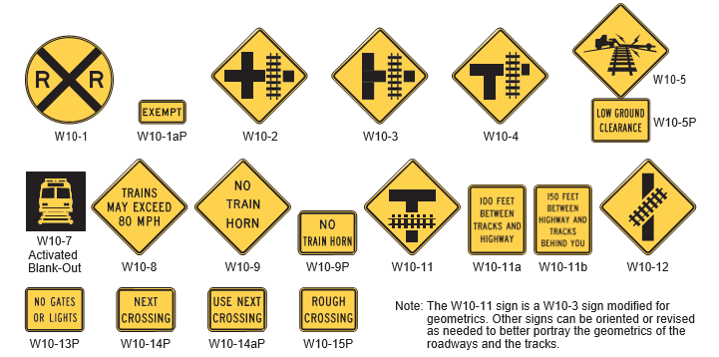
WARNING Signs and Plaques for Grade Crossings
Source: Figure 8B-4. Warning Signs and Plaques for Grade Crossings, MUTCD 2009 edition.
Reference the current edition of the MUTCD, Part 8 for additional information, detail, and options.

Other Signs, Plaques, and Devices for Grade Crossings

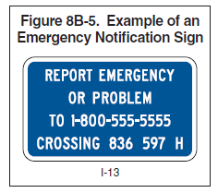
Emergency Notification signs should be installed at all highway-rail grade crossings. A minimum of USDOT grade crossing inventory number and the emergency contact telephone number should be included.

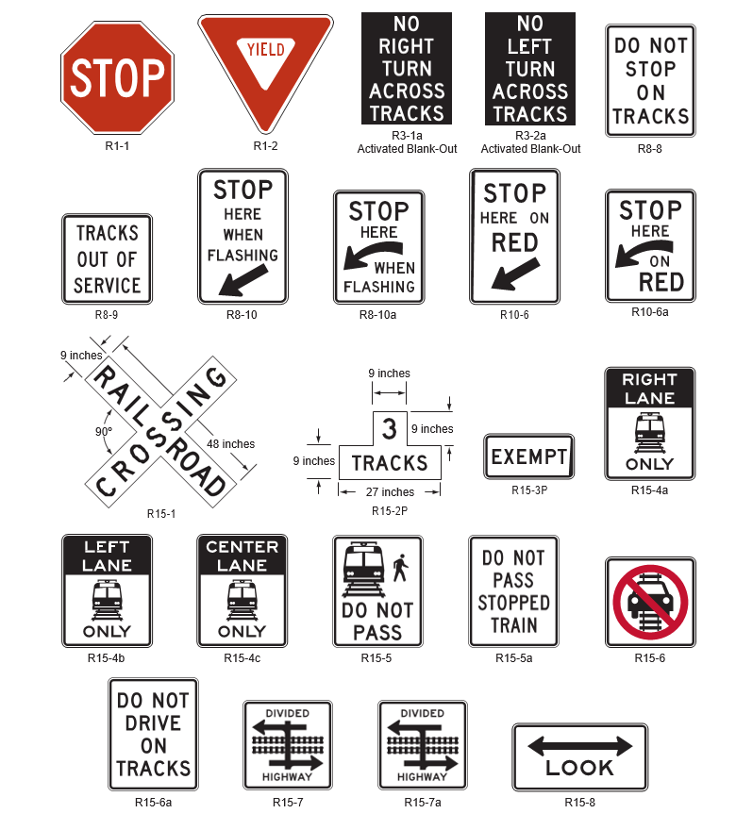
Regulatory Signs and Plaques for Grade Crossings
Source: Figure 8B-1. Regulatory Signs and Plaques for Grade Crossings, MUTCD 2009 edition.
Reference the current edition of the MUTCD, Part 8 for additional information, detail, and options.
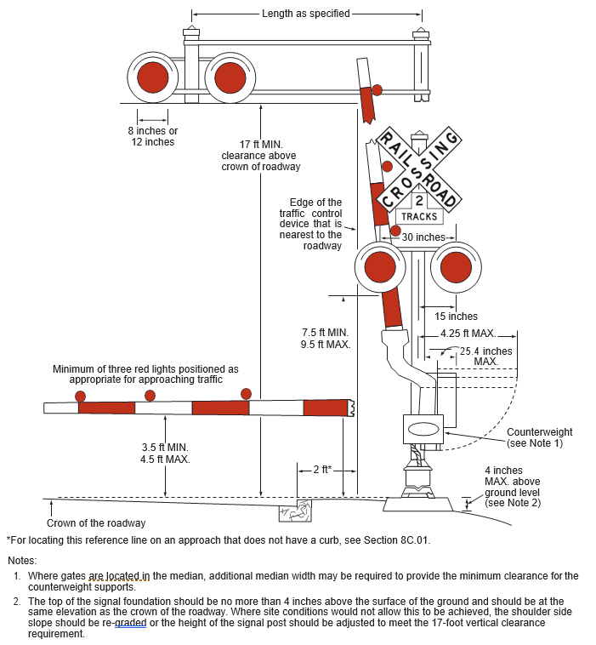
Source: Figure 8C-1. Composite Drawing of Active Traffic Control Devices, MUTCD 2009 edition.
Reference the current edition of the MUTCD, Part 8 for additional information, detail, and options.

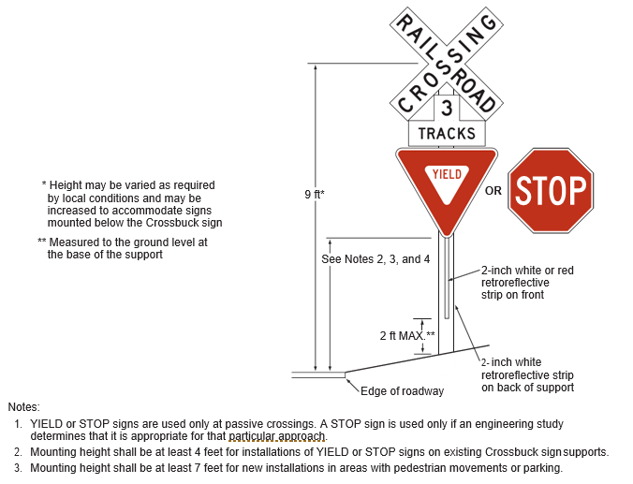
Source: Figure 8B-2. Crossbuck Assembly with Yield or Stop Sign on Crossbuck Sign Support, MUTCD 2009 edition.
Reference the current edition of the MUTCD, Part 8 for additional information, detail, and options.

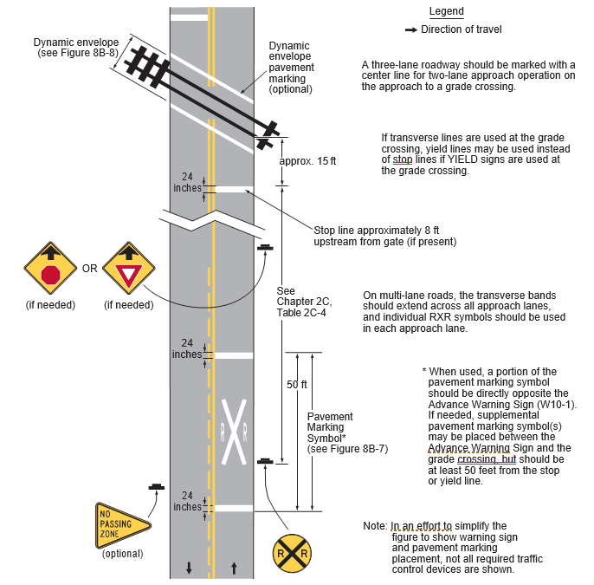
Source: Figure 8B-6. Example of Placement of Warning Signs and Pavement Markings at Grade Crossings, MUTCD 2009 edition.
Reference the current edition of the MUTCD, Part 8 for additional information, detail, and options.

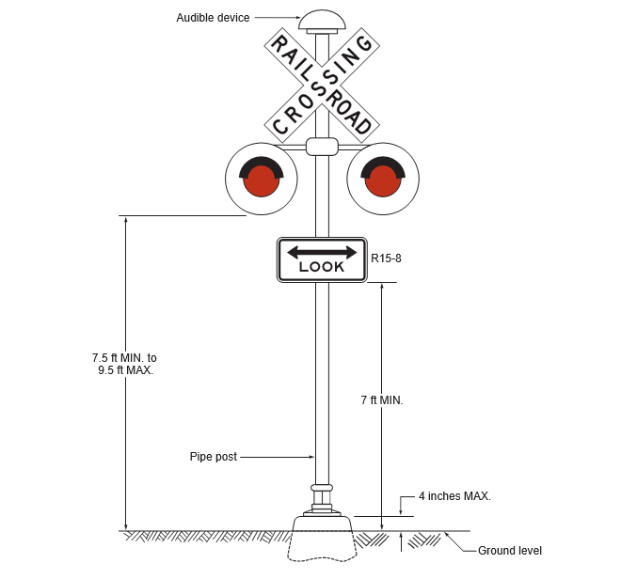
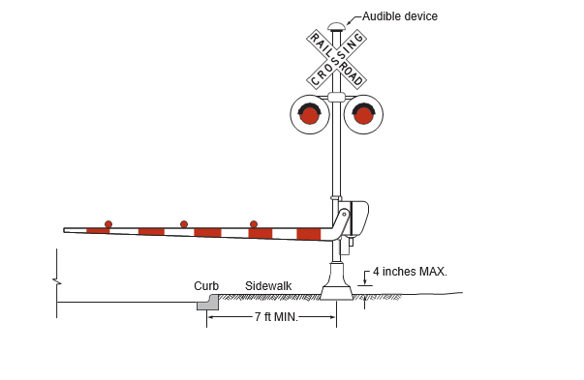
Source: Figure 8C-4 and 8C-5. Example of Flashing-Light Signal Assembly for Ped. Crossings and Shared Ped. Roadway Gate, MUTCD 2009 edition.
Reference the current edition of the MUTCD, Part 8 for additional information, detail, and options.

